**Name: Dhwani Patel**

**Collage: Silver Oak University**

Basic task python

Day 2

Print Hello World

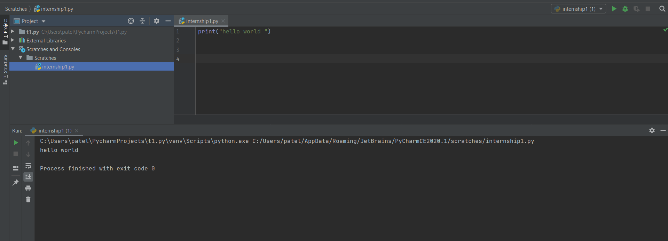

Variables

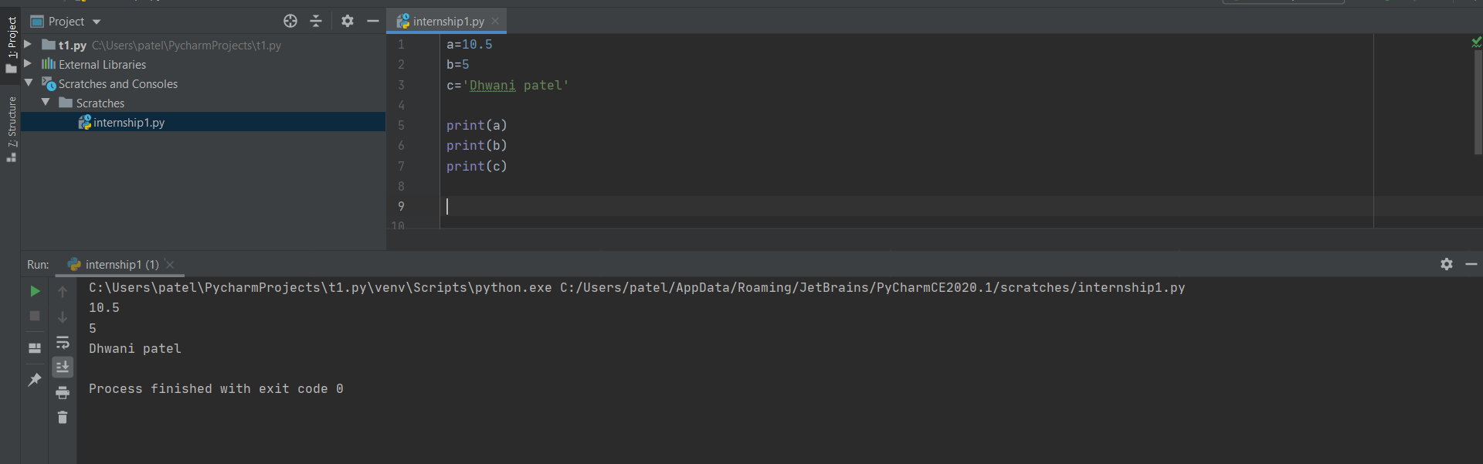

Changing the value of variable

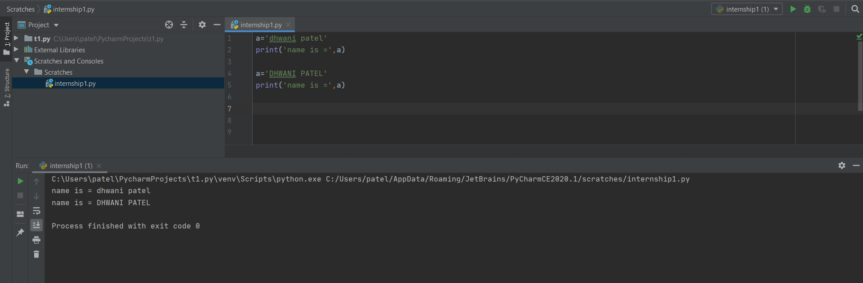

Assigning multiple values to multiple variables

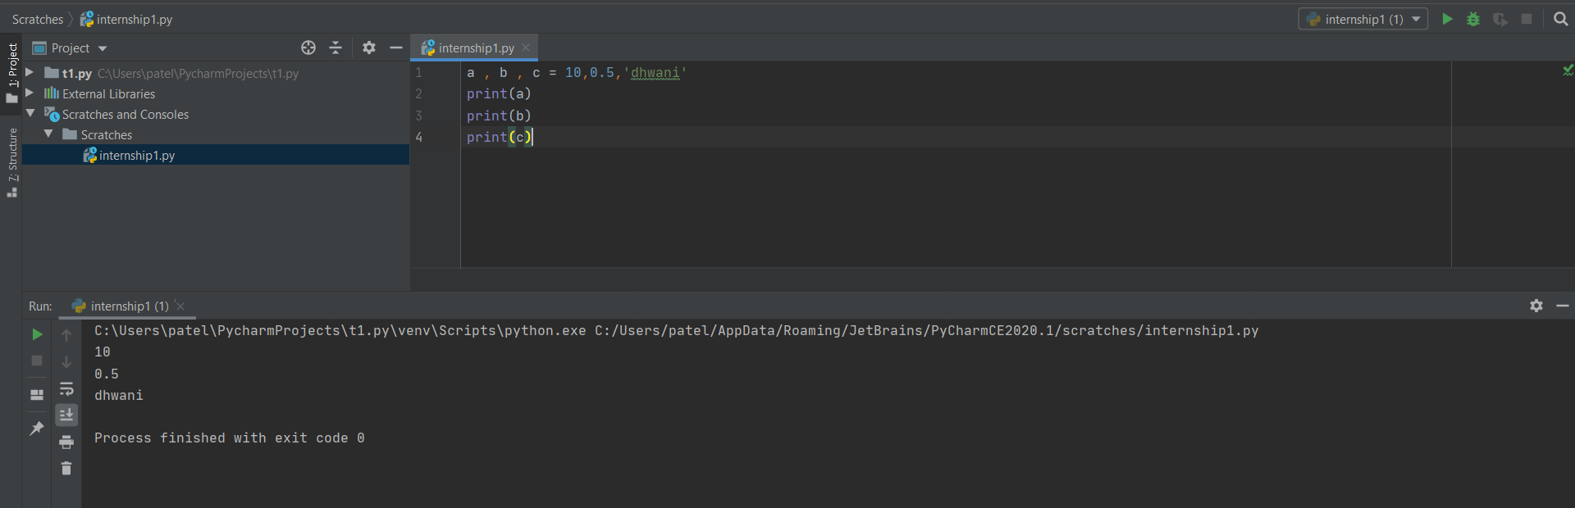

Assigning same values to multiple variables

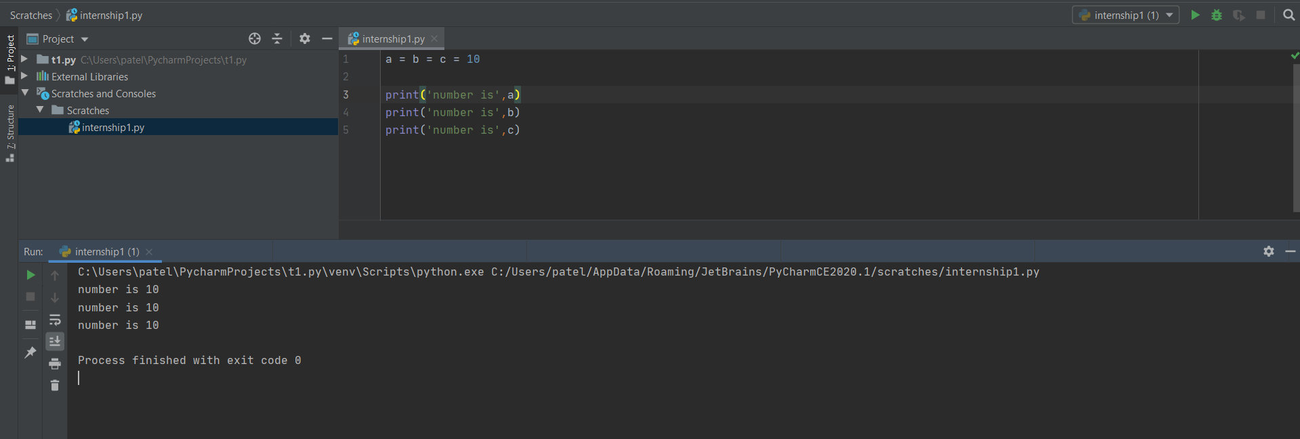

DATATYPES

* Number

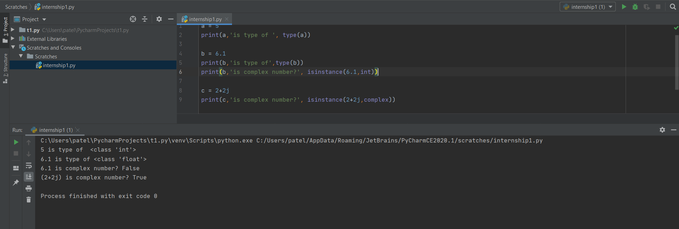

* String

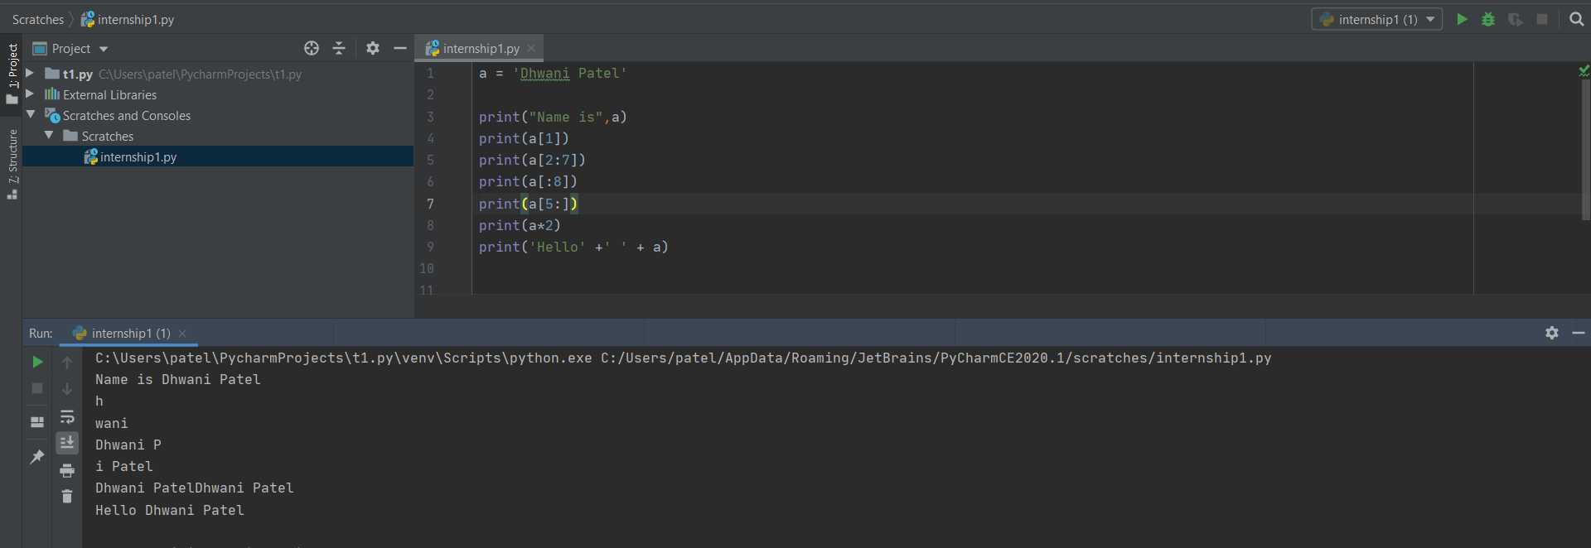

* List

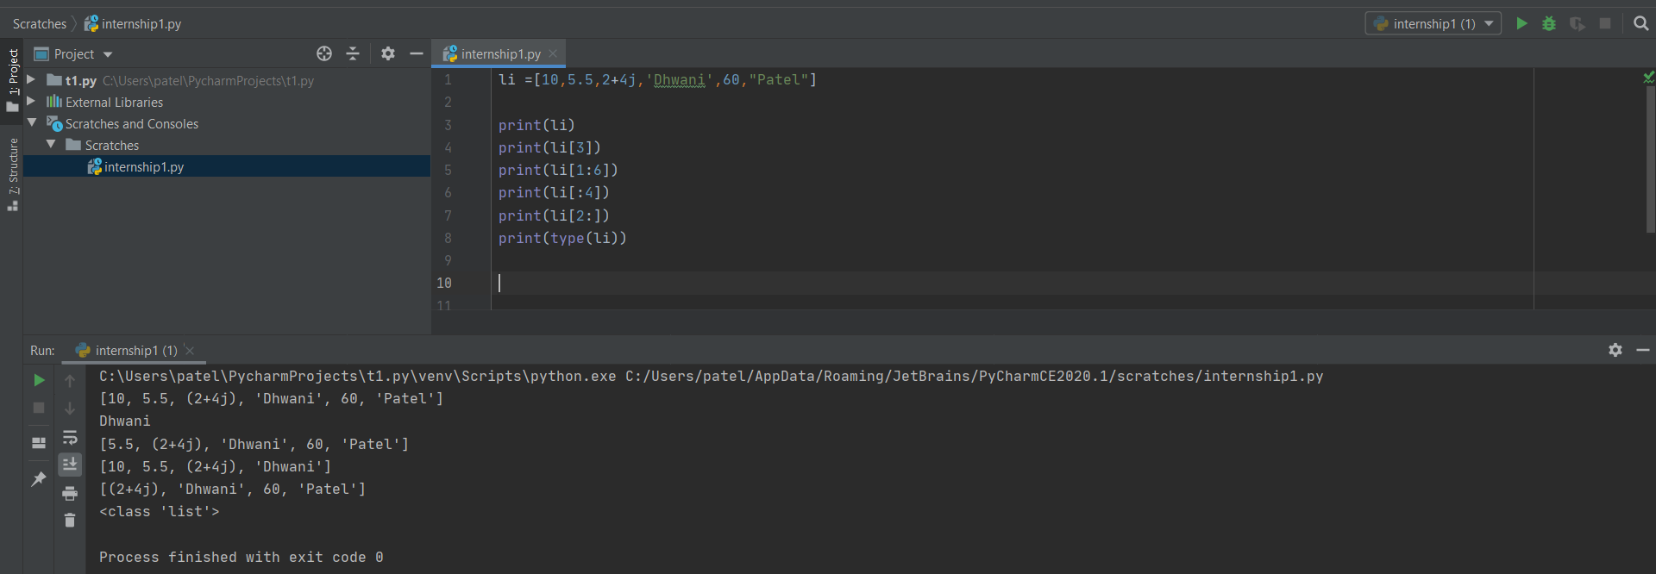

* Tuple

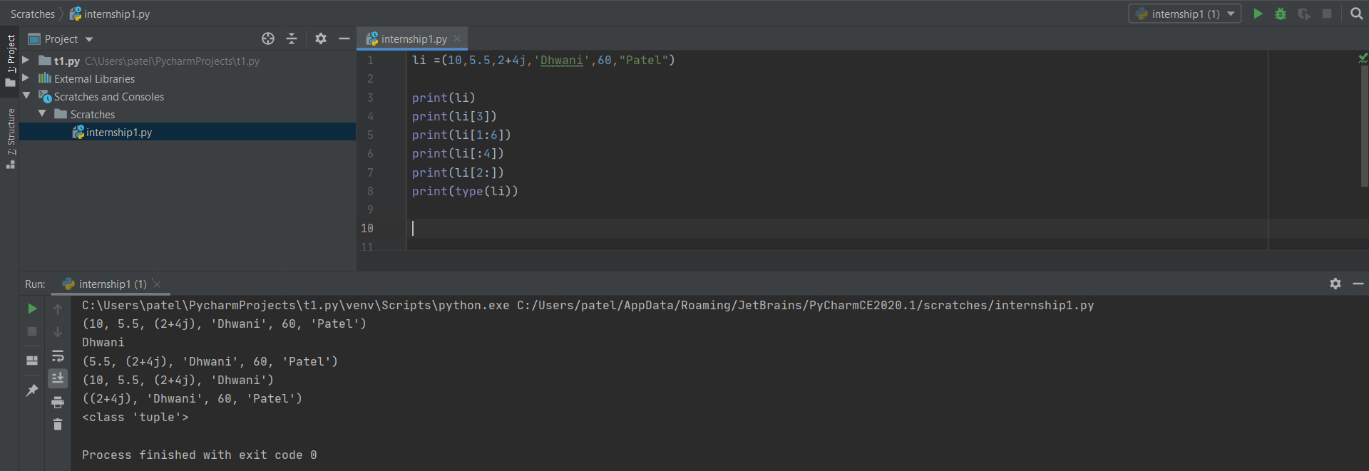

* Dictionary

